Welcome

Thank you for joining Second Harvest Food Bank of Middle Tennessee in the fight against hunger! With a little work and a lot of fun, we’re sure your Virtual Food Drive will make a big difference in the lives of those struggling with hunger in our community.

From students to churches to large corporations, we can all make an impact on hunger by combining our effort. Every dollar you raise through your drive will provide four meals to hungry children, families and seniors in Middle and West Tennessee. Your campaign will help raise awareness of hunger issues and encourage others to join the fight against hunger.

This manual contains easy-to-follow, step-by-step instructions for starting and managing a successful Virtual Food Drive.

Thank you again for choosing to make a difference in the lives of others.

Sincerely,
Nancy Keil
President & CEO
Second Harvest Food Bank of Middle Tennessee

Table of Contents

Getting Started
Registration Options _____________________ Page 3
Step-by-Step Instructions________________ Page 4

Participant Center
Tips & Tricks ___________________________ Page 5
Email Center ___________________________ Page 6

Best Practices
Checklist _____________________________ Page 7
Team Ideas ____________________________ Page 7

Social Media Posts ___________________________ Page 8

Getting Started

By registering your Virtual Food Drive, you will be the coordinator of the drive and food drive contact for Second Harvest Food Bank of Middle Tennessee.

We are here to support you in any way possible. If you have any additional questions or need guidance in setting up your Virtual Food Drive, please contact Jack Stell, Community Partnerships Manager at 615-627-1567 or via email at jack.stell@secondharvestmidtn.org.

Registration Options

Start a Virtual Food Drive online at http://secondharvestmidtn.org/act/donate-food/. Before you register, please take a moment to become familiar with the registration options below. If you are unsure of how you should register, just give us a call at 615-627-1567 and we will help you.

- Fundraise as an Individual
Choose this option if you want to support Second Harvest Food Bank through online fundraising. This option is for you if you want your friends and family to make a donation in lieu of buying gifts for your birthday, wedding, or other special occasion, or if you have a passion for feeding the hungry in your community and want the people in your network to join you. Be sure to personalize your fundraising page to share your personal story and encourage others to support your efforts.

- Fundraise as an Organization
Choose this option if you want to create a fundraising page for your whole company, school, or organization. Encourage everyone to donate to your organization’s fundraising page. Be sure to customize your page to share why your group is fundraising to help our hungry neighbors.

- Start a Competition
If you want to have a little friendly competition between friends or company departments, this is the registration option for you. Competitions maximize fundraising efforts, while offering the opportunity for bragging rights. This option allows you to create multiple fundraising pages, so you can track each team’s progress and see the combined results.

Step-by-step
1. Select the registration option that is best for you

2. Select Join as a New Participant

3. Fill out your registration form. On the second page of the form, you will create your username, password, display name. We recommend that your username be your email address and your display name be your organization or campaign name.

Once you complete your registration, you will be prompted to login to your Participant Center. You will also receive an email with your login information to access your Participant Center.
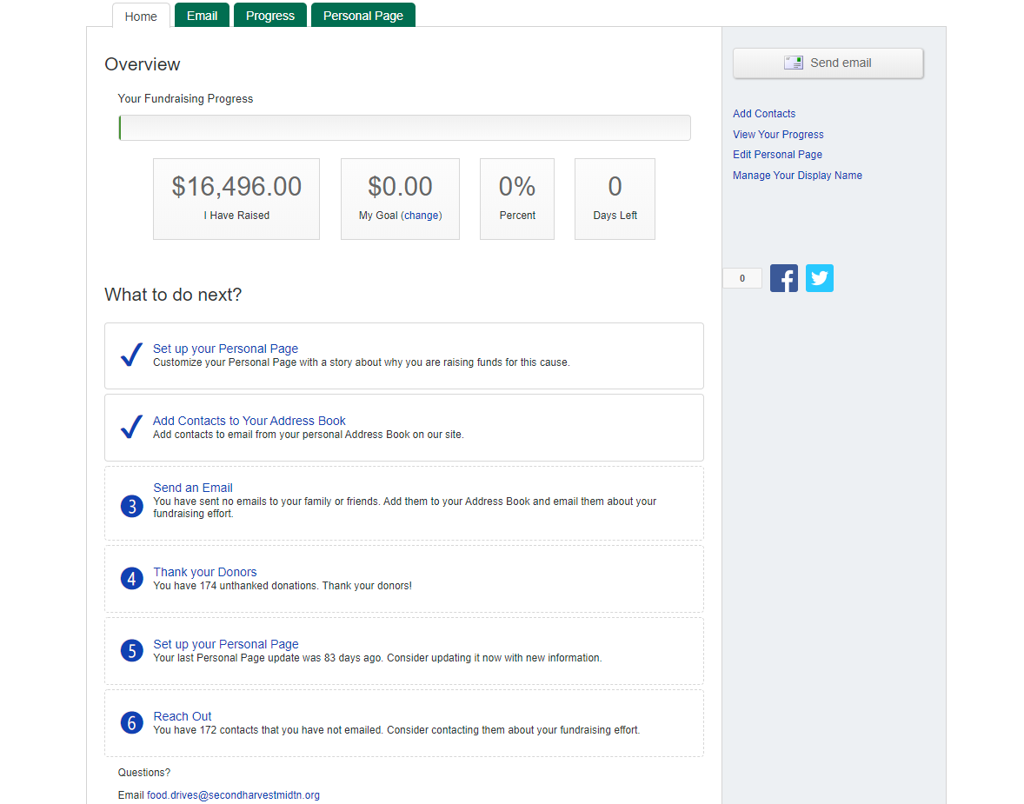

Participant Center

The Participant Center is your homepage where you can personalize your Virtual Food Drive fundraising and/or team (competition) page and spread the word on your campaign to get even more people involved.

Tips & Tricks
- Update your fundraising page
Replace the Second Harvest logo with your own photo or logo. Share a personal message to your supporters or the story behind starting your Virtual Food Drive.

- Track your progress.
View your donation history and see just how close you are to your goal.

- Create a short URL.
You will see your personal URL link by selecting the Personal Page tab. Make your fundraising page easier to share by customizing your URL with your company or campaign name. Send this unique URL to everyone participating in your Virtual Food Drive.

- Team Page
If you started a fundraising competition, you will also have the ability to edit your team page. Personalize your team page by explaining the competition and reminding everyone to donate to the correct fundraising page. This is a great place to get everyone fired up and ready for the competition!

Email Center
Use our email center to let your supporters know about your Virtual Food Drive! We have included some email templates so you can get started right away.

- Email friends and family to ask for support.
- Send thank you emails to all of your donors.
- Email your teammates to update the group on your achievements and to send words of encouragement!

You can import your contacts from Gmail, Yahoo or other email client.

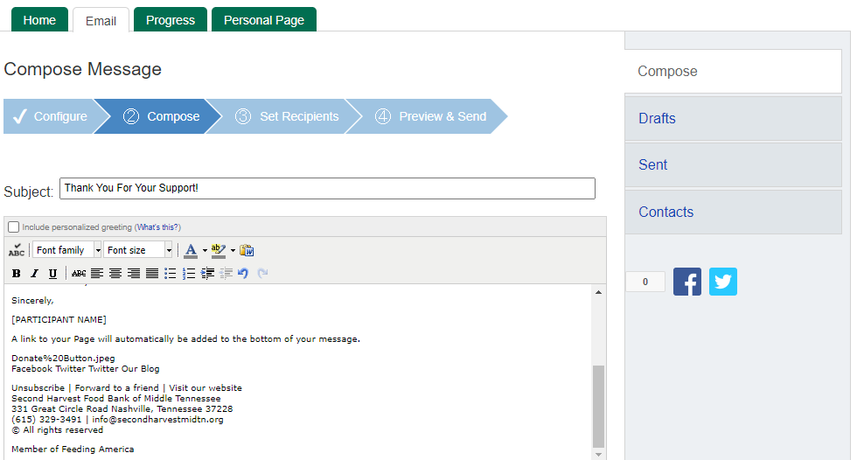

Best Practices

Checklist
A successful virtual food drive is easy to achieve with a little thoughtful planning.

- Set a goal. Set a goal you think is attainable. Goals are a fun way to get people pumped up about your drive. You will also have the option to change your goal at any time in your participant center.
- Set a date. Giving people a deadline creates urgency and will encourage them to support your drive in a timely matter.
- Update your Personal Page. Personalize your virtual food drive with your personal photo or team logo. Leave a message on your page that lets people know why you want to help feed families, children and seniors.
- Use the Email Center. We've provided you with ready-made messages, asking your contacts to donate to your virtual food drive.

Ideas to Encourage Participation
It is important to keep momentum going for your Virtual Food Drive. Use these ideas and think of others that could inspire the people around you to support the campaign and cause.

- Arrange a tour or volunteer shift at Second Harvest Food Bank to show members of your organization where their donations are going.

- Host “casual days” or “jean passes” in exchange for Virtual Food Drive donations.

- For teams, offer an incentive like a pizza party or an ice cream treat to encourage competition and increase the amount of money raised.

Social Media Posts
Posting about your Virtual Food Drive on social media is a great way to spread the word! Share hunger statistics, give an update on your progress or thank supporters. Always remember to include a link to your Virtual Food Drive page and be sure to tag Second Harvest Food Bank of Middle Tennessee @2HarvestMidTN so we can give you a shout out!

Facebook

- I’m/ (Our organization is) doing my part to help end hunger in our community. Show your support by donating to my/our Virtual Food Drive for Second Harvest Food Bank of Middle Tennessee. Every $1 can provide 4 meals to hungry children, families and seniors. (Insert your link).

- Over 350,000 people in Middle Tennessee don’t know where their next meal will come from. I’ve started a Virtual Food Drive to help end hunger in our community! (Insert your link)

- I’ve/we’ve reached more than 50% of our goal! Can you help me raise (goal amount) to help fight hunger in TN? (insert your link)

- It’s my birthday and I’m choosing to raise money to support the fight against hunger in TN. Help me reach my goal of (goal amount) by making a donation at (insert your link). Every $1 = 4 meals.

- Thanks to everyone who has supported my Virtual Food Drive for Second Harvest Food Bank of Middle Tennessee. Together we raised $___ to help feed those who are hungry in our community!

Twitter
- Help me feed hungry people in TN by supporting my Virtual Food Drive for @2HarvestMidTN (insert your link)

- I pledge to raise $ (goal amount) for our hungry neighbors in need. @2HarvestMidTn (insert your link)

- Big thanks to everyone who supported my Virtual Food Drive for @2HarvestMidTN. Together we raised X amount!

